KS4 GCSE Business Long Term Plan (Y11)
Business 2: Operations, Finance and Influences on Business (OCR J204/02)
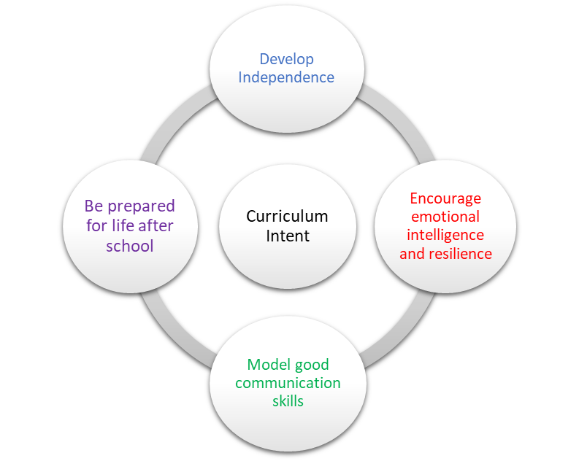 | School Pedagogy:  Launchpad Tuition has a child centred pedagogy. The school adopts an inclusive, transformative pedagogy as we believe that a child’s ‘capacity to learn can change and be changed for the better as a result of what happens and what people do in the present’ (Hart et al. 2004, P166). Learning is about shared communication between staff and pupils. Implementation of our curriculum intent is underpinned by Rosenshine’s 10 Principles of Instruction (Rosenshine, 2012). All learning sessions include the following elements; reference to curriculum intent, recap of knowledge and skills, assessment for learning and pupil voice.  Subject Specific Pedagogy:  - Scaffold learning as the course progresses to build understanding of the interdependent nature of business.  - For each unit, differentiate learning through dialogue and questioning at input stage and through tasks at revision stage.  - Embed assessment for learning through end of unit test feedback and target setting.  - Be inclusive and take the diverse needs of learners into account.
Subject Intent:
- To promote understanding of business concepts, business terminology, business objectives, the integrated nature of business activity and the impact of business on individuals and wider society
- To equip learners with the skills and confidence to explore how different business situations affect business decisions and draw on evidence to make informed business decisions and solve business problems
- To develop life skills that enable students to become financially and commercially aware.

Key Stage and Subject Long Term Plan | Topic/Learning Pathway | Key Vocabulary | Links to previous learning (Component Skills) | Links to wider curriculum
Autumn 1  Y11 | UNIT 4: OPERATIONS  4.1 Production processes  4.2 Quality of goods and services  4.3 The Sales process and Customer service  4.4 Consumer law  4.5 Business location  4.6 Working with suppliers | 4.1 Job, Batch and Flow production,  Automation, Robotics  4.2 Quality control, Quality assurance, Product Returns and Product Recalls  4.3 E-commerce, Telesales, Customer engagement,  4.5 Proximity to market and labour  4.6 Procurement, Supply chain, Logistics, Chain of distribution, | 1.5 Stakeholders (customers, employees, suppliers, government)  2.4 Marketing Mix (product)  3.5 Motivation  5.3 Revenue, Costs, Profit and loss | GCSE English Language  - Writing: Producing clear and coherent text  - Critical Reading and Comprehension: Supporting a point of view by referring to evidence within the text  GCSE Maths  - Calculations with numbers in standard form  - Percentages  - Interpret tables, charts and diagrams
Autumn 2  Y11 | REVISION  EXAM TECHNIQUE PRACTICE  END OF UNIT 4 TEST & FEEDBACK  UNIT 6: INFLUENCES ON BUSINESS  6.1 Ethical and Environmental considerations  6.2 The Economic climate  6.3 Globalisation  REVISION  EXAM TECHNIQUE PRACTICE  END OF UNIT 6 TEST & FEEDBACK | 6.1 Ethics, Sustainability  6.2 Economic climate, Unemployment, Consumer income, Gross Domestic Product  6.3 Globalisation, Multinational companies, International branding, | 1.5 Stakeholders (customers, employees, suppliers)  Unit 2 – Marketing  4.5 Business location | As Unit 4 above, plus:  GCSE Biology  - Global Challenges (maintaining the environment)
Spring 1  Y11 | REVISION OF PAPER ONE  MOCK EXAM  5.1 The role of the finance function  5.2 Sources of finance | 5.1 Start-ups, Expansion  5.2 Loan, Overdraft, Trade credit, Retained profit, Sale of assets, Owners’ capital, Share issue,  Crowdfunding | 1.3 Business Ownership
Spring 2  Y11 | 5.3a Revenue, costs, profit and loss (RECAP)  5.4 Break-even  5.5 Cash and cash flow  5.3a Profitability, Ratios and ARR  REVISION – PAST PAPERS | 5.3a Fixed and Variable costs  5.4 Break-even  5.5 Cash flow forecast, Liquidity  5.3b Profitability, Gross Profit, Net Profit, Profit Margins, Average rate of return | 1.4 Business Aims & Objectives | As Unit 4 above, plus:-  GCSE Maths  - Calculations with ratio
Summer 1  Y11 | REVISION – PAST PAPERS  (Until exams)

