KS4 GCSE Business Long Term Plan (Y10)
Business 1: Business Activity, Marketing and People (0CR J204/01)
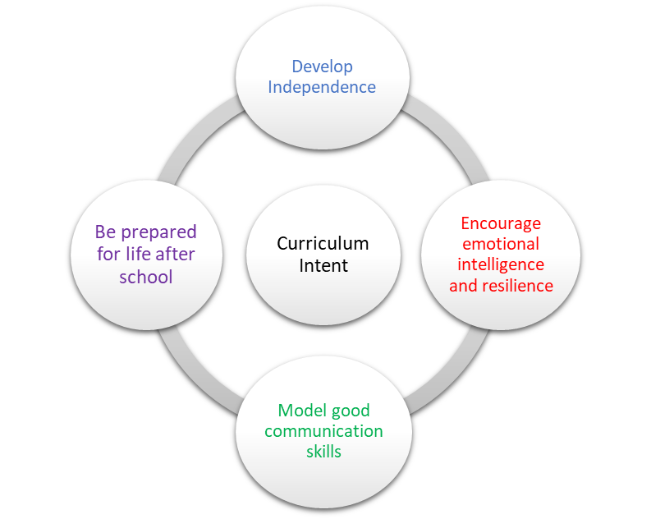 | School Pedagogy:  Launchpad Tuition has a child centred pedagogy. The school adopts an inclusive, transformative pedagogy as we believe that a child’s ‘capacity to learn can change and be changed for the better as a result of what happens and what people do in the present’ (Hart et al. 2004, P166). Learning is about shared communication between staff and pupils. Implementation of our curriculum intent is underpinned by Rosenshine’s 10 Principles of Instruction (Rosenshine, 2012). All learning sessions include the following elements; reference to curriculum intent, recap of knowledge and skills, assessment for learning and pupil voice.  Subject Specific Pedagogy:  - Scaffold learning as the course progresses to build understanding of the interdependent nature of business.  - For each unit, differentiate learning through dialogue and questioning at input stage and through tasks at revision stage.  - Embed assessment for learning through end of unit test feedback and target setting.  - Be inclusive and take the diverse needs of learners into account.
Subject Intent:
- To promote understanding of business concepts, business terminology, business objectives, the integrated nature of business activity and the impact of business on individuals and wider society
- To equip learners with the skills and confidence to explore how different business situations affect business decisions and draw on evidence to make informed business decisions and solve business problems
- To develop life skills that enable students to become financially and commercially aware.

Key Stage and Subject Long Term Plan | Topic/Learning Pathway | Key Vocabulary | Links to previous learning (Component Skills) | Links to wider curriculum
Autumn 1  Y10 | BASELINES & OVERVIEW OF COURSE  UNIT 1: BUSINESS ACTIVITY  - The role of business enterprise and entrepreneurship  - Business planning  - Business ownership  - Business aims and objectives (including 5.3 Revenue, costs, profit and loss)  - Stakeholders in business | 1.1: Business, Enterprise, Entrepreneur, Products and Services  1.2 Business Plan, Customers, Finance, Resources  1.3: Business ownership, Sole Trader, Partnership, Private Limited Company, Public Limited Company  Limited and Unlimited Liability, Debt  1.4 & 5.3: Costs, Revenue, Profit, Survival, Growth, Market Share  1.5: Internal and External Stakeholders, Employees, Suppliers | N/A | GCSE English Language  - Writing: Producing clear and coherent text  - Critical Reading and Comprehension: Supporting a point of view by referring to evidence within the text  GCSE Maths  - Calculations with numbers in standard form  - Percentages  - Interpret tables, charts and diagrams
Autumn 2  Y10 | - Business growth  REVISION  EXAM TECHNIQUE PRACTICE  END OF UNIT 1 TEST & FEEDBACK | 1.6: Horizontal and Vertical growth, Organic and External growth, Mergers, Takeovers, Diversification | N/A
Spring 1  Y10 | UNIT 2: MARKETING  2.1 The role of marketing  2.2 Market research  2.3 Market segmentation  2.4 The Marketing Mix | 2.2 Primary research, Secondary research, Trialling, Focus Groups, Census, Internal Data, Qualitative data, Quantitative data.  2.3 Market segmentation  2.4 Marketing Mix, Invention, Innovation, Branding, Product Life cycle, Price Skimming, Cost-Plus Pricing, Penetration Pricing, Competitor Pricing, Promotional Pricing, Point of Sale promotion, Loss Leaders, Print Media, Digital and Physical distribution channels | 1.4 Business Aims & Objectives  1.5 Stakeholders (customers)  5.3 Revenue, Costs, Profit
Spring 2  Y10 | 2.4 The Marketing Mix (continued)  REVISION  EXAM TECHNIQUE PRACTICE  END OF UNIT 2 TEST & FEEDBACK
Summer 1  Y10 | UNIT 3: PEOPLE  3.1 The role of human resources  3.2 Organisational structures and  different ways of working  3.3 Communication in business  3.4 Recruitment and  Selection | 3.1 Human resources  3.2 Tall and Flat organisation structures, Span of control, Chain of command, Delegation,  Subordinates, Authority, Flexible working, Self-employed  3.3 Digital communication  3.4 Recruitment, Skill gaps, Job description, Person specification, Referee | 1.5 Stakeholders (employees)
Summer 2  Y10 | 3.5 Motivation and Retention  3.6 Training and Development  3.7 Employment law  REVISION  EXAM TECHNIQUE PRACTICE  END OF UNIT 3 TEST & FEEDBACK | 3.5 Motivation, Fringe benefits, Employee retention, Staff turnover  3.6 Induction training, On the job/Off the job training, Staff development | 1.5 Stakeholders (employees)

