KS4 Year 11 Sociology Long Term Plan
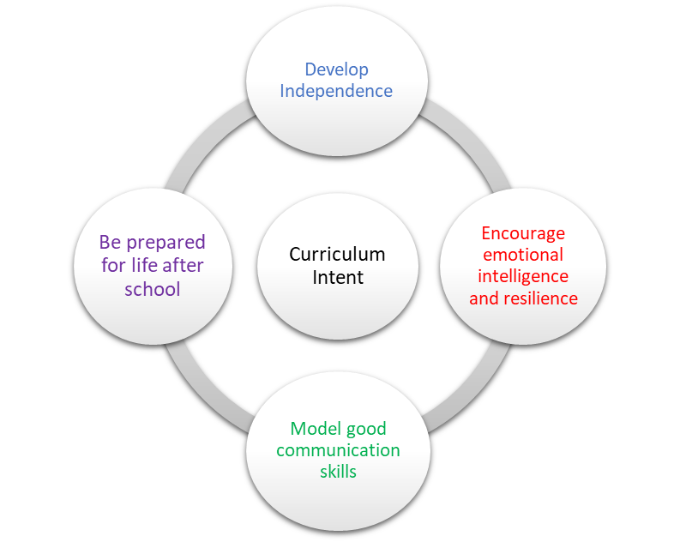 | School Pedagogy:  Launchpad Tuition has a child centred pedagogy. The school adopts an inclusive, transformative pedagogy as we believe that a child’s ‘capacity to learn can change and be changed for the better as a result of what happens and what people do in the present’ (Hart et al. 2004, P166). Learning is about shared communication between staff and pupils. Implementation of our curriculum intent is underpinned by Rosenshine’s 10 Principles of Instruction (Rosenshine, 2012). All learning sessions include the following elements; reference to curriculum intent, recap of knowledge and skills, assessment for learning and pupil voice.  Subject Specific Pedagogy:  Pupils are given the opportunity to discuss new ideas and concepts in class and staff put each topic into real life examples. Key words are reintroduced throughout the course and are explained using morphology. Many of these key words will be reinforced in different topics. Pupil’s will learn different sampling / research methods and will be able to produce their own research project. Different key thinkers will be studied and their ideas supported / challenged.
Subject Intent:
Sociology encourages our students to reflect upon society and how they fit into the world around them. It allows them the opportunity to consider why people may behave in certain ways and the possible reasons behind this behaviour. Students will challenge misconceptions and learn to support any opinions with actual evidence. Instead of just passively accepting the way the world works, they will become active thinkers considering what needs to change.

Key Stage and Subject Long Term Plan | Topic/Learning Pathway | Key Vocabulary | Links to previous learning (Component Skills) | Links to wider curriculum
Autumn 1 | How do we measure educational success?  Public examinations and league tables.  Ball on parental choice and competition between schools.  Outside the school what factors influence the chances of educational success?  Gender socialisation.  Material deprivation.  Parental attitudes.  Language development.  Employment, for example, as a motivational factor.  Government, for example, structural reforms to the education system.  Inside the school what factors influence the chances of educational success?  School ethos.  Hidden curriculum.  Setting and streaming.  Labelling and the self-fulfilling prophecy.  Pupil subcultures.  What is the link between social class and educational achievement?  Patterns of educational disadvantage related to socio-economic class.  The work of Halsey, Heath and Ridge.  What is cultural capital?  What is cultural deprivation?  What is material deprivation?  Working class subcultures.  Parental attitudes and language development (link to lesson 10).  Teacher/pupil interactions.  Ball on teacher expectations.  What is the gender based pattern of educational achievement?  Comparing the performance of boys and girls over time.  Patterns of subject choice.  How do we explain gender based differences in educational achievement?  Legal changes. For example:, employment opportunities for women and the National Curriculum.  Feminism and changing expectations/improved self-esteem.  Socialisation.  Hidden curriculum.  Teacher expectations and teacher-pupil interactions.  Gender based pupil subcultures.  What is the link between ethnicity and educational achievement?  High achieving ethnic groups.  Ethnic groups who are more likely to be excluded from school and to underachieve.  Impact of various home and school based factors linked to ethnicity.  Link to previous lessons on the impact of social class and gender on patterns of educational achievement.  A brief overview of the history of educational reform.  The introduction of compulsory education.  The raising of the school leaving age.  The tripartite system.  Comprehensive schools.  National curriculum.  Academies, faith and free schools.  Student grants/loans and access to higher education. | League table  Public examinations  SATs  Gender  Social class  Socialisation  Counter school cultures  Ethos  Hidden curriculum  Labelling  Self-fulfilling prophecy  Setting  Streaming  Educational achievement  Socio-economic class  Cultural capital  Cultural deprivation  Interactionism  Social inequality  Subculture  Educational achievement  Gender  Feminism  Gender  Hidden curriculum  Socialisation  Subculture  Questionnaire  Interview  Ethnicity  Exclusion  Academy  Comprehensive school  Compulsory state education  Education reform  Tripartite system | Primary socialisation  Class system  Marxism  Feminism  Culture | Maths  Business  English Language  Science  History  Health and Social  Childcare
Autumn 2 | What is the difference between crime and deviance?  Defining crime and deviance.  Time, place, culture and social situation.  How is crime measured?  Official crime statistics.  Why do sociologists use official statistics on crime?  What are the problems associated with official statistics on crime?  What are victim surveys?  What are the advantages and disadvantages of victim surveys?  What are the advantages and disadvantages of self-report studies?  What do sociologists mean when they say that crime and deviance are socially constructed?  Refer back to lesson 1.  Explore examples of the changing definition of crime and deviance. For example: drug and alcohol consumption, suicide and homosexuality.  How has criminal and deviant behaviour been explained?  Biological explanations.  Psychological explanations.  How has criminal and deviant behaviour been explained?  Sociological explanations.  The ideas of Merton and Becker.  Socialisation.  Anomie.  Peer groups and criminal subcultures.  Status frustration.  Labelling.  How do sociologists explain differences in criminal behaviour between social classes?  Link to sociological explanations of crime (lesson 6).  Official statistics.  White collar crime.  How do sociologists explain differences in criminal behaviour between men and women  The ideas of Heidensohn.  Link to sociological explanations of crime (lesson 6).  Official statistics.  Opportunity.  Control theory.  Chivalry thesis.  Poverty.  Statistical patterns of crime and criticisms of statistics  Links to sociological explanations of crime (lesson 6).  Official statistics.  Institutional racism.  Stereotypes (police and media). | Crime  Deviance  Culture  Dark figure  Official statistics  Recorded crime  Reported crime  Self-report study  Victim survey  Crime  Deviance  Social construct  n/a  Anomie  Interactionism  Labelling  Subculture  Socialisation  Status frustration  Anomie  Interactionism  Labelling  Subculture  Social class  Socialisation  Status frustration  White collar crime  Chivalry thesis  Control theory  Gender  Ethnicity  Institutional racism  Stereotypes | Research methods  Culture  Society  Functionalism  Interactionism  Secondary socialisation  Anti-school subculture  Feminism
Spring 1 | How do sociologists explain differences in criminal behaviour between different age groups?  Link to sociological explanations of crime (lesson 6).  Status frustration.  Risk taking behaviour by young people (‘edgework’).  Stereotypes (police and media).  What is informal social control?  Family.  Peer group.  Schools.  Workplace.  Religion.  What is formal social control?  Police.  Court system.  Home Office.  Ministry of Justice.  Serious Fraud Office.  How should society respond to criminal behaviour by young people?  Albert Cohen on delinquent subcultures.  Punishment or education?  Age of criminal responsibility.  Youth custody.  What is the prison system designed to achieve?  Punishment.  Reform.  Alternatives to prison.  How should society respond to violent crime?  Sentencing violent offenders.  Mandatory prison sentences.  How accurate is the reporting of crime by the media?  Sensationalism.  Deviancy amplification.  Moral panic.  Violence media content.  What are functionalist ideas about crime and deviance?  Boundaries and values.  Social cohesion.  Deviant behaviour as a ‘safety valve’.  Strain theory.  Subculture theory.  How do Marxist sociologists explain criminal and deviant behaviour?  Criticisms of Marxist explanations.  How do Interactionist sociologists explain criminal and deviant behaviour?  Criticisms of Interactionist explanations.  How do Feminist sociologists explain criminal and deviant behaviour?  The ideas of Carlen.  Criticisms of Feminist explanations. | Status frustration  Stereotypes  Social control  Social control  Criminal justice system  Prison system  Youth crime  Prison system  Probation system  Criminal justice system  Prison system  Deviancy amplification  Media  Moral panic  Functionalism  Feminism  Interactionism  Marxism | Anti-school subculture  Role of the media  Functionalism  Feminism  Interactionism  Marxism
Spring 2 | What is social stratification?  Different types of social stratification:  • slavery  • caste  • estates  • class.  Why do functionalists believe that social stratification is a ‘universal necessity’?  The ideas of Davis and Moore.  Criticisms of Davis and Moore.  Inequalities in income between different groups.  What is socio-economic class?  Who is in the ‘upper class’?  Who is in the ‘middle class’?  Who is in the ‘working class’?  National statistics and the classification of socio-economic class.  What is the Marxist view of socio-economic class?  Means of production.  Division of labour.  Capitalism.  Class conflict.  Polarisation of social classes.  Alienation.  Crisis of capitalism.  Communism.  Criticisms of Marx.  What is Weber’s view of socio-economic class?  Market situation.  Life chances.  Status, values and lifestyle.  Party (any organised group that seeks to exercise power).  Criticisms of Weber.  What are the various factors affecting life chances?  Is Britain a meritocratic society?  Social class.  Various other factors affecting life chances. For example: gender, ethnicity and age.  Are the working class becoming more like the middle class (link to life chances)?  The idea of embourgeoisement (Goldthorpe et al).  Instrumental attitudes.  Privatism (home centred).  Class identity.  Criticisms of the theory of embourgeoisement (Devine).  What is social mobility?  Vertical mobility.  Intra-generational mobility.  Intergenerational mobility.  Rates of social mobility.  The Social mobility and Child poverty commission.  What is absolute poverty?  What is relative poverty?  Measuring poverty.  Explaining poverty.  Why do sociologists use a relative measure of poverty?  The ideas of Townsend on relative deprivation.  Criticisms of Townsend.  Who is in the ‘underclass’?  The ideas of Murray on welfare reform and the underclass.  Criticisms of Murray.  What is globalisation?  Criticisms of globalisation.  The impact of globalisation on the UK. | Achieved status  Aristocracy  Caste  Class  Elite  Feudalism (estates)  Slavery  Social inequality  Stratification  Functionalism  Income  Inequality  Stratification  Elite  National statistics  Socio-economic class  Bourgeoisie  Capitalism  Class struggle (conflict)  Communism  Marxism  Petty-bourgeoisie  Proletariat  Life chances  Lifestyle  Market situation  Status  Values  Ageism  Meritocracy  Racism  Sexism  Affluence  Embourgeoisement  Social class  Working class  Social mobility  Absolute poverty  Poverty trap  Relative deprivation (poverty)  Deprivation  Lumpen proletariat  New Right  Marxism  Nation state  Neo-liberalism  Privatisation | Class system  Functionalism  Marxism  Marx  Weber  Class system  Functionalism  New Right  Marxism
Summer 1 | What is the welfare state?  New Right perspectives on welfare.  Centre-left perspectives on welfare.  Marxist and feminist perspectives on welfare.  How did Weber define power?  Rational (legal) authority.  Traditional authority.  Charismatic authority.  Criticisms of Weber.  What is political power?  The nation state.  Democracy.  Constitution.  What is a political party?  Political parties in the U.K.  Elections  Voting behaviour  What are power relationships?  Various factors affecting power relationships. For example: social class and gender.  Elite groups and power.  Interest groups.  What is patriarchy?  The ideas of Walby.  Feminism.  Gender and power. | Feminism  Marxism  New Right  Welfare state  Bureaucracy  Charismatic authority  Dictatorship  Elite  Traditional authority  Dictatorship  Feudalism  Member of Parliament  Monarchy  Nation state  Prime minister  Political party  Political socialisation  Elite  Interest (or pressure) groups  Power relationships  Feminism  Gender  Patriarchy  Power | Weber  Power  Feminism
Summer 2 | Revision and exam skills

