KS4 Year 10 Sociology Long Term Plan
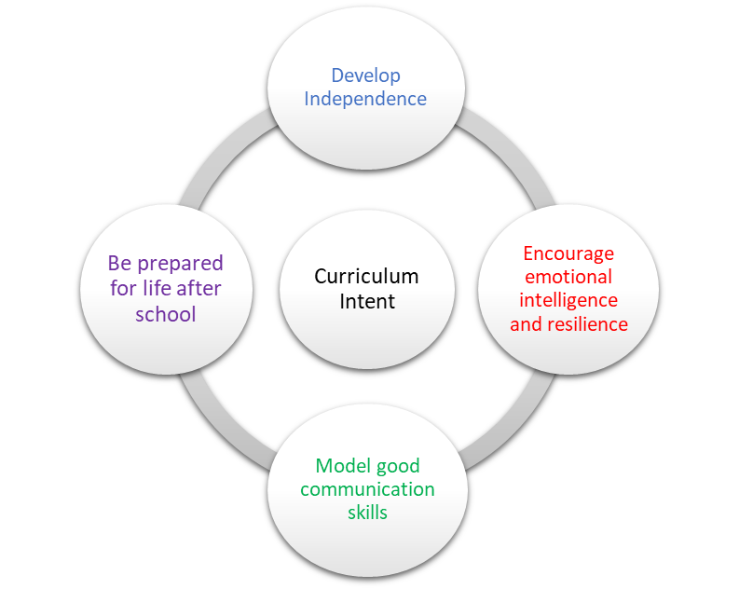 | School Pedagogy:  Launchpad Tuition has a child centred pedagogy. The school adopts an inclusive, transformative pedagogy as we believe that a child’s ‘capacity to learn can change and be changed for the better as a result of what happens and what people do in the present’ (Hart et al. 2004, P166). Learning is about shared communication between staff and pupils. Implementation of our curriculum intent is underpinned by Rosenshine’s 10 Principles of Instruction (Rosenshine, 2012). All learning sessions include the following elements; reference to curriculum intent, recap of knowledge and skills, assessment for learning and pupil voice.  Subject Specific Pedagogy:  Pupils are given the opportunity to discuss new ideas and concepts in class and staff put each topic into real life examples. Key words are introduced throughout the course and are explained using morphology. Many of these key words will be reinforced in different topics. Pupil’s will learn different sampling / research methods and will be able to produce their own research project. Different key thinkers will be studied and their ideas supported / challenged.
Subject Intent:
Sociology encourages our students to reflect upon society and how they fit into the world around them. It allows them the opportunity to consider why people may behave in certain ways and the possible reasons behind this behaviour. Students will challenge misconceptions and learn to support any opinions with actual evidence. Instead of just passively accepting the way the world works, they will become active thinkers considering what needs to change.

Key Stage and Subject Long Term Plan | Topic/Learning Pathway | Key Vocabulary | Links to previous learning (Component Skills) | Links to wider curriculum
Autumn 1 | What is sociology?  How do we define what sociology is and what do sociologists study?  How did sociology develop? (A brief history.)  Looking at the world through the eyes of a sociologist.  Why is Durkheim seen as a ‘founder’ of sociology and what were some of his important ideas?  Durkheim and his world.  Why is Marx seen as a ‘founder’ of sociology and what were some of his important ideas?  Marx and his world.  Why is Weber seen as a ‘founder' of sociology and what were some of his important ideas?  Weber and his world.  An introduction to Functionalism.  Was Durkheim a functionalist?  Who was Talcott Parsons and what was his contribution to sociology?  Criticisms of Functionalism.  An introduction to Marxism.  Marxist sociology (explore examples).  Historical attempts to create a society based on Marxist ideas.  Criticisms of Marxism.  An introduction to Interactionism.  Labelling theory (explore examples of how labelling can affect the behaviour of students).  Criticisms of Interactionism.  An introduction to Feminism.  What is patriarchy?  Are men and women equal in Great Britain today?  An introduction to the New Right.  The culture of poverty.  The underclass.  Criticisms of the New Right. | Culture  Norms  Role  Social construct  Society  Anomie  Crime and deviance  Division of labour  Functionalism  Bourgeoisie  Capitalism  Communism  Economy  Proletariat  Wealth  Working class  Authority  Power  Social order  Value consensus  Marxism  False class consciousness  Ruling class ideology  Labelling  Master status  Gender  Patriarchy  Polygamy  Culture  Culture of dependency  Culture of poverty  Identity  Neo-liberalism and neo-conservatism  Underclass | Marxism  Functionalism  Marxism | Maths  Business  English Language  Science  History  Health and Social  Childcare
Autumn 2 | What is a social structure?  Different forms of social stratification.  Race and ethnicity.  What is a social process?  Social control.  Socialisation.  Nature versus nurture.  What is a social issue?  Poverty as a social issue.  Crime as a social issue.  Media amplification and moral panics.  What is a conflict perspective?  What is a consensus perspective?  ‘Grand theories’ and ideas about progress.  What is qualitative research?  What is quantitative research?  What is culture? (Refer back to lesson 1.)  Nature v nurture (refer back to lesson 11).  Feral children.  Sociobiology.  What is the difference between biological sex and gender?  Culture and gender roles.  Gender identity.  Feminist perspectives on gender roles.  What is race? (Link to lesson 10.)  What is ethnicity?  What are the key decisions to make before beginning a research project?  Establishing appropriate aims.  Formulating a hypothesis. | Caste  Ethnicity  Feudal system  Gender  Social class  Social stratification  Culture  Mass media  Sanctions  Social control  Socialisation  Values  Poverty  Crime  Media amplification  Moral panic  Relative deprivation  Conflict  Consensus  Sociological debate  Case study  Official statistics  Reliability  Validity  Culture  Socialisation  Culture  Feminism  Gender  Discrimination  Ethnicity  Immigration  Racism  Scapegoat  Stereotype  Functionalism  Interactionism  Values  Bias  Ethics  Hypothesis  Validity | Functionalism  Feminism  Marxism  What is Sociology  Culture  Feminism  Culture
Spring 1 | What is the scientific method?  Why is peer review important?  What is the importance of a pilot study (planning for success and avoiding problems)?  What makes research ‘reliable’?  What makes research ‘valid’?  How do we assess the success or failure of sociological research?  Choosing the right research tools.  Grounded theory (link to previous lesson – alternative approaches).  Avoiding bias.  Using secondary sources appropriately.  Keeping costs under control.  What is the British Sociological Association Ethical Code (provide a summary of main points)?  The principle of informed consent.  The Nuremburg Code.  The need for anonymity and confidentiality.  The Data Protection Act (summary of key principles).  What are primary sources?  Different types of primary data.  Reliability (refer back to lesson two).  Validity (refer back to lesson 2).  Representative population samples (introduce this idea – to be followed up and developed at a later point).  Research using mixed methods (advantages).  What are secondary sources?  Different types of secondary source material.  The need for critical review when using secondary sources  What are surveys?  Postal and online questionnaires.  Telephone surveys.  Opinion polls.  Advantages and disadvantages of surveys.  Why do sociologists use sample surveys (link to lesson 7)?  What is a sampling frame?  Different types of probability samples (known populations).  Non-probability samples (unknown populations).  What is a questionnaire (as a research tool)?  When is a questionnaire an appropriate research tool?  How to design a questionnaire.  What are the advantages of questionnaires?  What are the disadvantages of questionnaires?  What is an interview (as a research tool)?  Different types of interviews (structured, unstructured and semi-structured).  Focus groups.  The problem of interviewer bias.  The advantages of interviews.  The disadvantages of interviews.  What is observation (as a research tool)?  Different types of observation (participant and non-participant).  What is an observation schedule?  The advantages of observation.  The disadvantages of observation. | Informed consent  Interactionism  Reliability  Validity  Bias  Secondary sources  Ethics  Informed consent  Confidentiality  Case study  Interview  Longitudinal study  Mixed methods  Observation  Questionnaire  Representative sample  Triangulation  Content analysis  Official statistics  Secondary sources  Sample  Representative data  Quota sample  Random sample  Representative  Sampling frame  Snowball sample  Systematic sample  Closed question  Confidentiality  Informed consent  Open questions  Focus group  Interview  Unstructured interviews  Non-participant observation  Observer effect  Participant observation | Hypothesis  Reliability  Validity  Surveys
Spring 2 | What is quantitative data (key terms and ideas)?  Presenting quantitative data.  Looking for patterns and trends.  What is a case study (as a research tool)?  When is it appropriate to use a case study?  What are the advantages of case studies?  What are the disadvantages of case studies?  What is a longitudinal study (as a research tool)?  When is it appropriate to use a longitudinal study?  What are the advantages of longitudinal studies?  What are the disadvantages of longitudinal studies?  What is ethnography (as a research tool)?  When is it appropriate to use an ethnographic approach?  What are the advantages of ethnography?  What are the disadvantages of ethnography?  What is an experiment (as a research tool)?  Examples of famous (social science) experiments.  Ethical problems associated with social science experiments.  Small scale research  How do sociologists define a family?  What is a household?  Different family structures.  What are the different types of family found in the UK?  The Rapoports' five types of family diversity (organisational, cultural, social class, life cycle and family life course).  Criticisms of the Rapoports' work.  How have changes in the law affected the family. Think about divorce, equal pay and same-sex marriage.  Changing social values and attitudes.  Changing gender roles.  Benefits for lone parents.  Employment opportunities.  Longer life expectancy.  Decline in religion.  Immigration.  What is a nuclear family?  Is the nuclear family still important?  The media and the nuclear family.  The family life cycle.  Why might people live in a lone person household?  Communal living.  The Kibbutz.  House shares.  Residential homes. | Quantitative data  Case study  Longitudinal study  Representative data/sample  Social mobility  Ethnography  Ethics  Attitude survey  Questionnaire  Interview  Cohabitation  Family  Family diversity  Reconstituted (or blended) family  Lone parent family  Divorce  Family diversity  Marriage  Divorce  Gender equality  Gender roles  Immigration  Life expectancy  Same sex marriage  Lone parents  Values and attitudes  Nuclear family  Mass media  Commune  Kibbutz | Questionnaire  Bias  Analysis
Summer 1 | How do families differ in other cultures?  What is the Functionalist theory of the family?  The ideas of Murdock.  The ideas of Parsons.  Primary socialisation.  The stabilisation of adult personalities.  Criticisms of the functionalist theory of the family.  What is the Marxist theory of the family?  Criticisms of the Marxist theory of the family.  The ideas of Zaretsky.  What is the Feminist theory of the family?  The ideas of Delphy and Leonard.  Criticisms of the Feminist theory of the family.  How have relationships within families changed over time?  Pre-industrial families (1600 to 1800).  Industrialised families (post-1800).  Contemporary families.  Relationships between parents and children.  Is marriage in decline?  How important is marriage in contemporary British society?  Why has the pattern of divorce changed since 1945?  Legal changes.  Changing social attitudes and values.  Loss of traditional family functions (loosening of the ‘ties that bind’).  Secularisation.  What are the consequences of divorce?  Consequences for parents and family members.  Lone parent families.  Consequences for children.  What do functionalist sociologists say about divorce?  What do Marxist sociologists say about divorce?  What do feminist sociologists say about divorce?  What are conjugal roles?  What are traditional family roles?  Oakley on the idea of the conventional family.  Joint conjugal roles.  The dual burden.  What is the symmetrical family?  The ideas of Young and Willmott.  Suggested reasons for the rise of the symmetrical family.  The principle of stratified diffusion.  Criticisms of Young and Willmott. | Culture  Functionalism  Primary socialisation  Marxism  Feminism  Family relationships  Symmetrical family  Stratified diffusion  Patriarchy  Arranged marriage  Cohabitation  Monogamy  Same-sex marriage  Serial monogamy  Divorce  Social attitudes  Values  Secularisation  Divorce  Lone parent family  Functionalism  Marxism  Feminism  Conjugal roles  Dual burden  Joint conjugal roles  Segregated conjugal roles  Traditional family roles  Symmetrical family  Stratified diffusion | Culture  Functionalism  Marxism  Feminism  Functionalism  Marxism  Feminism
Summer 2 | How have relationships within families changed over time?  Power relationships and decision making within families.  Changing status of women in society.  Domestic violence.  What do functionalist sociologists say about conjugal roles?  Evaluating functionalist ideas.  What do Marxist sociologists say about conjugal roles?  Evaluating Marxist ideas.  What do feminist sociologists say about conjugal roles?  Evaluating feminist ideas.  Small scale research  Why do we have schools?  Functionalism and education (Durkheim and Parsons).  Social cohesion.  Skills for employment.  How do schools act as an agency of socialisation?  Core values.  Meritocracy.  What is the relationship between education and capitalism?  What do Marxist sociologists say about education?  The correspondence principle (Bowles and Gintis).  Criticisms of the Marxist view of education.  Evaluating functionalist views of education.  Evaluating Marxist views of education.  Evaluating feminist views of education.  Identifying various types of state school, including primary, secondary, comprehensive, academies and faith schools.  Selective education.  Private education.  Identifying various alternative forms of education including:  • de-schooling  • home schooling  • democratic schools, such as Summerhill  Arguments for and against private education.  Comparing social costs, opportunities and outcomes. | Power relationships  Status  Conjugal roles  Functionalism  Marxism  Conjugal roles  Feminism  Questionnaire  Interview  Compulsory state education  Functionalism  Social cohesion  Secondary socialisation  Values  Meritocracy  Capitalism  Correspondence principle  Marxism  Feminism  Functionalism  Marxism  School  State school  Selection  Private school  De-schooling  Home schooling  State school  Private school | Symmetrical families  Questionnaire  Bias  Analysis  Primary socialisation  Marxism  Feminism  Functionalism  Marxism  Marxism

