Key Stage 4 and Subject Long-Term Plan for English Language GCSE Year 11
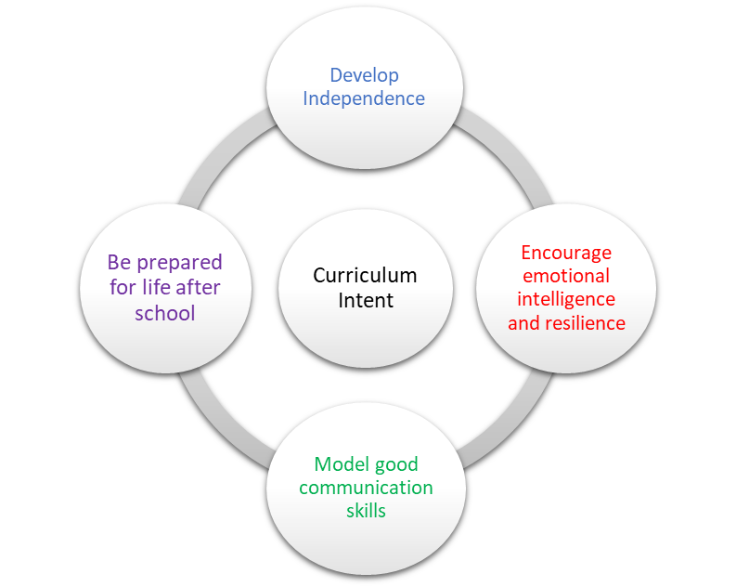 | School Pedagogy:  Launchpad Tuition has a child centred pedagogy. The school adopts an inclusive, transformative pedagogy as we believe that a child’s ‘capacity to learn can change and be changed for the better as a result of what happens and what people do in the present’ (Hart et al. 2004, P166). Learning is about shared communication between staff and pupils. Implementation of our curriculum intent is underpinned by Rosenshine’s 10 Principles of Instruction (Rosenshine, 2012). All learning sessions include the following elements; reference to curriculum intent, recap of knowledge and skills, assessment for learning and pupil voice.  Subject Specific Pedagogy:  Pupils start each lesson with a review of learning in their last lesson using a variety of methods. New material is presented in small chunks with a focus on what, how and why questions to check understanding. Modelling is used to support pupils to practice new skills. Pupils are given ample opportunities to practice those new skills with regular feedback from their teacher. Scaffolding resources are available to support independent practice of reading, writing and spoken language skills. Pupils review prior learning at the beginning and the end of each topic to demonstrate explicit links between their learning. Tier 2 and Tier 3 vocabulary is taught within lessons.  Subject Intent:  The English department in each of our facilities aim to promote a passion for English within all students at Alternative Provision. The love of the subject is nurtured and will build on the vital foundations that students have already laid at Key Stages 1 and 2. The English department want all students to feel empowered by what they study, developing creativity for both the written and spoken word. Our students are immersed in a broad curriculum that allows them to research and theorise about the relationship between a writer’s context and their writing style. Students will develop the skills of empathy and enquiry for current literature as well as a thirst to know more about a world that has gone before them.

Key Stage and Subject Long-Term Plan | Topic/Learning Pathway | Key Vocabulary | Links to previous learning (Component Skills) | Links to wider curriculum
Autumn  1 & 2 | Content and Skills for Paper 2, Section A – reading  Intention:  •To build confidence in reading complex texts and to expand vocabulary  •To promote an interest of reading texts that apply to the real world, outside of the school setting  •To help to develop pupils’ curiosity of non-fiction texts with regards bias, subjectivity, objectivity, and point of view  •To develop skimming and scanning reading skills when comparing texts  •Many of the texts in this unit involve SCMS as they all relate to the real world both contemporary and pre-1914  Content  - Skills for question 1 texts – Preparation for Question to establish basic skills in selecting and retrieving explicit information  - Skills for Question 2 - to identify appropriate supporting quotations and how to present them.  - Make and present inferences about ideas and attitudes by developing inferential skills when reading texts presenting viewpoints  - Summarise and synthesise selecting and collating information from more than one text  - To expand basic comprehension skills to enable you to deal with more than one text at a time  - Attempt two past question 2’s and mark according to the mark scheme.  Intention:  •To build confidence in reading complex texts and to expand vocabulary  •To promote an interest of reading texts that apply to the real world, outside of the school setting  •To help to develop pupils’ curiosity of non-fiction texts with regards bias, subjectivity, objectivity, and point of view  •To develop skimming and scanning reading skills when comparing texts  •Many of the texts in this unit involve SCMS as they all relate to the real world both contemporary and pre-1914  •The skills acquired in this unit will help pupils to be better writers in Section B of this paper  Content:  - Skills for question 3 (the SSI formula will be used throughout this question) - Identify the overall viewpoint in a text. To write about the effects of writer's language choices, linking them to the overall viewpoint.  - Identify and explain the effect of language techniques in a non-fiction text. To comment on these techniques in your own writing.  - Attempt two exam question 3s and mark according to the marks scheme  - Skills for Question 4 - recognise differences and similarities in viewpoint and perspectives  - How to write to evaluate  - Evaluate a writer’s use of linguistic devices, tone, and emotive language  - Question 4 guided practice  - Attempt two past question 4s | Tier 2  Identify, interpret, explicit, implicit information, synthesise, select, judicious  Tier 3  Discourse markers – whereas, similarly, however, contrastingly, on the other hand, conversely, but  Tier 2 vocabulary  Explain, comment, analyse, judicious  Tier 3 vocabulary  Nouns, verbs, adjectives, adverbs, simile, metaphor, personification, onomatopoeia, alliteration, assonance, sentence structure, repetition, symbolism, characterisation, juxtaposition, oxymoron, appeal to the senses, rhythm  Tier 2 vocabulary  Compare, ideas, perspectives, convey  Tier 3 vocabulary  Facts, opinions, rhetorical language, tone, nouns, verbs, adjectives, adverbs, simile, metaphor, personification, onomatopoeia, alliteration, assonance, sentence structure, repetition, symbolism, characterisation, juxtaposition, oxymoron, appeal to the senses, rhythm | Reading  Read and appreciate the depth and power of non-fiction through reading a wide range of high-quality, challenging non-fiction texts.  Understand and critically evaluate  texts through:  - reading in different ways  for different purposes,  summarising and  synthesising ideas and  information, and  evaluating their usefulness  for particular purposes  - drawing on knowledge of  the purpose, audience for  and context of the writing,  including its social,  historical and cultural  context and the literary  tradition to which it  belongs, to inform evaluation  identifying and  interpreting themes and  ideas  - exploring aspects of plot,  characterisation, events  and settings, the  relationships between  them and their effects  - seeking evidence in the  text to support a point of  view, including justifying  inferences with evidence  - analysing a writer’s choice  of vocabulary, form,  grammatical and structural  features, and evaluating  their effectiveness and  impact  - referring to the contexts,  themes, characterisation,  style and literary quality of  texts, and drawing on  knowledge and skills from  wider reading  - make an informed  personal response,  recognising that other  responses to a text are  possible and evaluating  these.  Writing  - adapting their writing for a  wide range of purposes  and audiences: to describe,  narrate, explain, respond  to information, and argue  - selecting and organising  ideas, facts, and key points,  and citing evidence, details  and quotation effectively  and pertinently for support  and emphasis  - using Standard English  where appropriate  - make notes, draft and  write, including using  information provided by  others [e.g., writing a letter  from key points provided.  drawing on and using  information from a  presentation]  - paying attention to the  accuracy and effectiveness  of grammar, punctuation  and spelling.  - use linguistic and literary  terminology accurately and  confidently in discussing reading, writing and  spoken language.  Spoken English  - speak confidently, audibly  and effectively, including  through using Standard  English when the context  and audience require it  - working effectively in  groups of different sizes  and taking on required  roles, including leading and  managing discussions,  involving others  productively, reviewing  and summarising, and  contributing to meeting  goals/deadlines  - listening to and building on  the contributions of  others, asking questions to  clarify and inform, and  challenging courteously  when necessary  - listening and responding  in a variety of different  contexts, both formal and  informal, and evaluating content, viewpoints, evidence, and aspects of presentation. | Sociology, Science, History
Spring 1 | Question 5 - Point of View writing, Paper 2, Section B  Intention:  •To build confidence in reading writing point of view texts and utilise vocabulary and skills acquired in Section A  •To allow pupils to have an opinion and to voice an opinion in a constructive and safe way  •To develop confidence when speaking and listening to debate and discussion of the real topics in the world (SMSC)  Content:  - Learn what point of view writing entails and how it relates to the exam assessment objectives  - Select the right tone and register when you express a point of view  - Select suitable features which match forms and conventions  - Utilise powerful and interesting vocabulary for discursive or persuasive writing and switch between telling and showing readers how you feel.  - Vary your verbs and sentences to convey your viewpoint to influence the reader  - Use different forms of punctuation to explain your ideas or support your point of view  - Organise points and ideas in a range of ways and to create links across your text as a whole  - Order sentences to explain or stress points or ideas and to link to sentences together so your ideas are clear and logical  - Apply the skills from this chapter to two unseen English Language task and reflect on your progress through looking at different responses to the task. | Tier 2 Vocabulary  Purpose, audience, form, perspective  Tier 3 Vocabulary  Discourse markers – whereas, similarly, however, contrastingly, on the other hand, conversely, but, etc. Nouns, verbs, adjectives, adverbs, simile, metaphor, personification, onomatopoeia, alliteration, assonance, sentence structure, repetition, symbolism, characterisation, juxtaposition, oxymoron, appeal to the senses, rhythm, rhetorical questions, anecdotes, imaginary scenario, circular structure, facts, opinions, |  | Sociology
Spring 2 | Intense Revision for Paper 1 and Individual catch-up sessions
Summer 1 | Intense Revision for Paper 2  Exams and Individual catch-up sessions
Summer 2 | n/a

