Key Stage and Subject Long-Term Plan for GCSE English Language Year 10
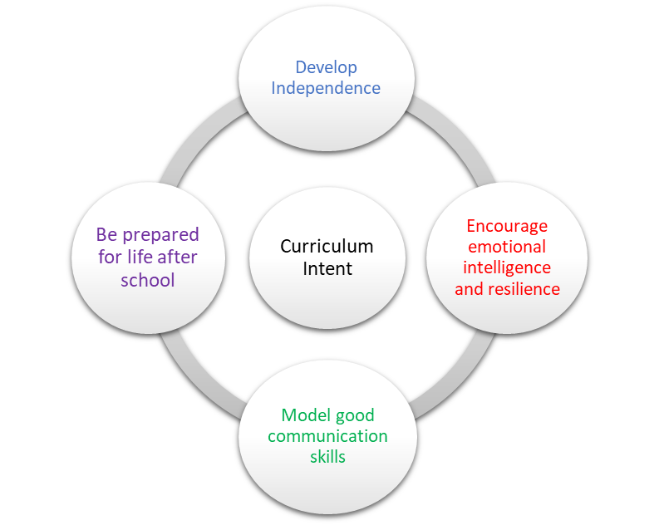 | School Pedagogy:  Launchpad Tuition has a child centred pedagogy. The school adopts an inclusive, transformative pedagogy as we believe that a child’s ‘capacity to learn can change and be changed for the better because of what happens and what people do in the present’ (Hart et al. 2004, P166). Learning is about shared communication between staff and pupils. Implementation of our curriculum intent is underpinned by Rosenshine’s 10 Principles of Instruction (Rosenshine, 2012). All learning sessions include the following elements: reference to curriculum intent, recap of knowledge and skills, assessment for learning and pupil voice.  Subject Specific Pedagogy:  Pupils start each lesson with a review of learning in their last lesson using a variety of methods. New material is presented in small chunks with a focus on what, how and why questions to check understanding. Modelling is used to support pupils to practice new skills. Pupils are given ample opportunities to practice those new skills with regular feedback from their teacher. Scaffolding resources are available to support independent practice of reading, writing and spoken language skills. Pupils review prior learning at the beginning and the end of each topic to demonstrate explicit links between their learning. Tier 2 and Tier 3 vocabulary is taught within lessons.  Subject Intent:  The English department in each of our facilities aim to promote a passion for English within all students at Alternative Provision. The love of the subject is nurtured and will build on the vital foundations that students have already laid at Key Stages 1 and 2. The English department want all students to feel empowered by what they study, developing creativity for both the written and spoken word. Our students are immersed in a broad curriculum that allows them to research and theorise about the relationship between a writer’s context and their writing style. Students will develop the skills of empathy and enquiry for current literature as well as a thirst to know more about a world that has gone before them.

Key Stage and Subject Long-Term Plan | Topic/Learning Pathway | Key Vocabulary | Links to previous learning (Component Skills) | Links to wider curriculum
GCSE Year 10  Autumn  1 & 2 | Dystopia Genre  Intention:  •To use extracts and ideas from dystopia novels to develop pupils’ reading and writing skills  •To explore the heritage of the dystopia genre and how it applies to real issues and concerns in the world around us  •The genre touches on social, cultural, moral, and spiritual issues, therefore SMSC will be explored throughout  •To make pupils think about the world around them and the choices governments and people in power make or don’t make than can have devastating consequences  •Pupils will also get a cross-curricular look at science, history, politics, and media which allow them to explore the wider world around them  Content  - Learn what is meant by the word ‘dystopia’.  - Understand what is meant by a 'utopia'.  - Look at how writers can use adverbs, adverbial phrases, and sentence length to control the pace of the action in a narrative  - How writers can use adverbs, adverbial phrases, and sentence length to control the pace of the action in a narrative  - Features of a dystopian narrative  - Features of dystopia novels and their influence for an idea for a new novel  - How writers use nouns and noun phrases to influence the reader's view of the fictional  - How choice of pronouns, nouns and verbs can influence the reader's response to characters and their points of view  - Utilise the skills learned so far to create the opening paragraph for their own dystopian story.  - How writers use dialogue to convey characters' thoughts and feelings  - How language can be used to manipulate people through political language  - How proper nouns can be chosen to convey a structured society in an imaginary world.  - How writers can create a sense of fear by controlling the release of information to the reader.  - How to plan a dystopian story by exploring four different blurbs  - Planning the rest of their dystopia story by looking at setting, ideas, and values in their society then use the four-part model to help to structure effectively  - Write the opening chapter to a dystopian story  - Create front cover and blurb (and possible last chapter – extension task) | Tier 2  Connotation, inference, denotation, dystopia, utopia, Marxism, communism, Stalinism, eugenics, themes, point of view, political language, blurb, propaganda  Tier 3  Noun phrases, adjectives, nouns, setting, adverbs, adverbial phrases, sentence structure for dramatic effect, pronouns, verbs, characterisation, dialogue, structure, repetition, exposition, conflict, climax, resolution | Reading  Read and appreciate the depth and power of fiction through reading a wide range of high-quality, challenging, classic and contemporary literature.  Understand and critically evaluate  texts through:  - reading in different ways  for different purposes,  summarising and  synthesising ideas and  information, and  evaluating their usefulness  for purposes  - drawing on knowledge of  the purpose, audience for  and context of the writing,  including its social,  historical and cultural  context and the literary  tradition to which it  belongs, to inform evaluation  identifying and  interpreting themes and  ideas  - exploring aspects of plot,  characterisation, events  and settings, the  relationships between  them and their effects  - seeking evidence in the  text to support a point of  view, including justifying  inferences with evidence  - analysing a writer’s choice  of vocabulary, form,  grammatical and structural  features, and evaluating  their effectiveness and  impact  - referring to the contexts,  themes, characterisation,  style and literary quality of  texts, and drawing on  knowledge and skills from  wider reading  - make an informed  personal response,  recognising that other  responses to a text are  possible and evaluating  these.  Writing  - adapting their writing for a  wide range of purposes  and audiences: to describe,  narrate, explain, respond  to information, and argue  - selecting and organising  ideas, facts, and key points,  and citing evidence, details  and quotation effectively  and pertinently for support  and emphasis  - using Standard English  where appropriate  - make notes, draft and  write, including using  information provided by  others [e.g., writing a letter  from key points provided.  drawing on and using  information from a  presentation]  - paying attention to the  accuracy and effectiveness  of grammar, punctuation  and spelling.  - use linguistic and literary  terminology accurately and  confidently in discussing reading, writing and  spoken language.  Spoken English  - speak confidently, audibly  and effectively, including  through using Standard  English when the context  and audience require it  - working effectively in  groups of different sizes  and taking on required  roles, including leading and  managing discussions,  involving others  productively, reviewing  and summarising, and  contributing to meeting  goals/deadlines  - listening to and building on  the contributions of  others, asking questions to  clarify and inform, and  challenging courteously  when necessary  - listening and responding  in a variety of different  contexts, both formal and  informal, and evaluating content, viewpoints, evidence, and aspects of presentation. | Sociology, Science, Art, History
Spring 1 & Spring 2 | What the Dickens? Using the Works of Charles Dickens to learn all the skills for the reading section of Paper 1  Intention:  •Using the Works of Charles Dickens to learn all the skills for the reading section of Paper 1  •To encourage enjoyment when understanding, analysing, and evaluating literary texts.  •To build confidence in reading complex texts and to expand vocabulary  •To experience Britain’s Literary Heritage and the social and historical context of Victorian Britain  •To promote a love of reading and persuade pupils to expand their reading outside of school  •To help to develop pupils’ creativity when writing  •SCMS is discussed throughout the texts of Dickens as much of his work was a social commentary of the day  Content  Skills for question 1 of paper 1 section A (Reading).  - Social and historical context in which Charles Dickens was writing. Introduce the skills for question 1 – ‘list four things’  - Skills for Question 2 – ‘How writers use language to…’  - (The SSI formula will be used throughout the skills for this question)  Focus on characters of Charles Dickens. Use inferential skills to explore and analyse use of language to create a character  - Describe and present a character(s). Utilise the techniques Dickens has used to present several different characters using names from Dickens novels.  - ‘How writers use language to …’ Focus on setting and atmosphere  - Attempt two questions from past paper 1 – question 1 & 2 (marked according to mark scheme)  - Skills for question 3 – ‘How does the writer structure this extract to interest you as a reader’. (The formula Where, What, Why? Will be use throughout teaching the skills for this question)  - Identify how writers use structural features for effect through Dickens extracts, photographs, and film clips  - Attempt two questions from past paper 1 – question 3 (marked according to mark scheme)  - Skills for question 4 – ‘To what extent do you agree’. To evaluate texts critically. (The formula agreement, reason, method, quotation, inference will be utilised throughout this question)  - The skills will be applied to the poem Havisham by Carol Ann Duffy and extracts from Great Expectations, Oliver Twist and A Christmas Carol.  - Attempt two questions from past paper 1 – question 4 (marked according to mark scheme) | Tier 2 vocabulary  Identify, interpret explicit, implicit information, synthesise  Tier 2 vocabulary (question 2)  Explain, comment, analyse, infer, connote, describe, judicious  Tier 3 vocabulary  Nouns, verbs, adjectives, adverbs, simile, metaphor, personification, onomatopoeia, alliteration, assonance, sentence structure, repetition, symbolism, characterisation, juxtaposition, oxymoron, appeal to the senses, rhythm.  Tier 2 vocabulary (question 3)  Explain, comment, analyse, infer, connote, judicious  Tier 3 vocabulary (question 3)  Freytag Pyramid, zooms in/out, foreshadows, flashback,  Contrast, repetition of idea, shift in time/mood/theme, circular structure, inciting incident,  rising action, climax, falling action, resolution, inside to outside, internal thought external action  Tier 2 vocabulary  Evaluate critically  Tier 3 vocabulary  (All the vocabulary specified in questions2-3) Also a range of discourse markers – additionally, on the other hand, however, although, conversely, furthermore, in summary, alternatively, consequently, etc. | (All the skills learned in the dystopia unit will now be re-iterated and expanded in order that pupils apply these skills in a focussed way to understand the requirements for each question)  summarising and  synthesising ideas and  information, and  evaluating their usefulness  Analysing a writer’s choice  of vocabulary, form,  grammatical and structural  features, and evaluating  their effectiveness and  impact  Analysing a writer’s choice  of vocabulary, form,  grammatical and structural  features, and evaluating  their effectiveness and  impact  Understand and critically evaluate  texts through:  seeking evidence in the  text to support a point of  view, including justifying  inferences with evidence  - analysing a writer’s choice  of vocabulary, form,  grammatical and structural  features, and evaluating  their effectiveness and  impact  make an informed  personal response,  recognising that other  responses to a text are  possible and evaluating  these. | History. Sociology
Summer 1 | Creative Writing – Skills for answering paper 1, question  Intention:  •To allow pupils to utilise and develop the vocabulary, sentence structure, linguistic devices, structural devices, and poetic devices they have been studying in Section A of this paper  •To develop confidence in student’s creative writing abilities  •To promote a love of the creative text  •To develop a wider vocabulary  Content  - Re-cap of techniques which we could use to make our writing effective acquired in Section A  - Use visual stimulus to influence creative writing  - Learn to create drama and suspense in my writing.  - revise structural features in writing  - Applying structural techniques to visual stimulus by creating two differing types of plan  - Novel Openings : Analyse several famous novel openers and explain why they are effective  - What the Examiners said will look at what the examiners are looking for  - Analyse exemplar answers and establish how they have been marked by using the mark scheme  - Apply all the skills acquired in this unit to answer 2 questions 5s.  - Self-evaluation using mark scheme before teacher assessment | Tier 2 vocabulary  Purpose, audience, form  Tier 3 vocabulary  Nouns, verbs, adjectives, adverbs, simile, metaphor, personification, onomatopoeia, alliteration, assonance, sentence structure, repetition, symbolism, characterisation, juxtaposition, oxymoron, appeal to the senses, rhythm, Freytag Pyramid, zooms in/out, foreshadows, flashback,  Contrast, repetition of idea, shift in time/mood/theme, circular structure, inciting incident, rising action, climax, falling action, resolution, inside to outside, internal thought external action, crafting | To allow pupils to utilise and develop the vocabulary, sentence structure, linguistic devices, structural devices, and poetic devices they have been studying in Section A of this paper.  Writing  - adapting their writing for a  For the purpose to describe  and audiences: to describe,  - using Standard English  where appropriate  - make notes, draft and  write, including using  information provided by  Section A, of paper 1  - paying attention to the  accuracy and effectiveness  of grammar, punctuation  and spelling.  - use linguistic and literary  terminology accurately.
Summer 2 | Speaking & Listening: ‘Talking About My Generation’.  Intention:  •To allow pupils to utilise and develop the vocabulary and their confidence when expressing an opinion verbally Section A of this paper  •To explore the social and cultural world around them and have a voice on these topics (SCMS)  Content  - A contribution to a TV programme that is aimed at the youth of today. It is called Talking About My Generation and it is looking for young people, aged 14-21, to talk for 5 minutes about a subject they are passionate about that is prevalent to their generation.  - Talk to explain, inform, persuade, argue, or advise.  - Preparation and practice time given  - Marked according to AQA pass, merit distinction | Tier 2 vocabulary  Standard English, purpose, audience, form, point of view | Spoken English  -speak confidently, audibly  and effectively, including  through using Standard  English when the context  and audience require it  - working effectively in  groups of different sizes  and taking on required  roles, including leading and  managing discussions | Sociology, Science, PSHE

