Year 10 Maths Long Term Plan
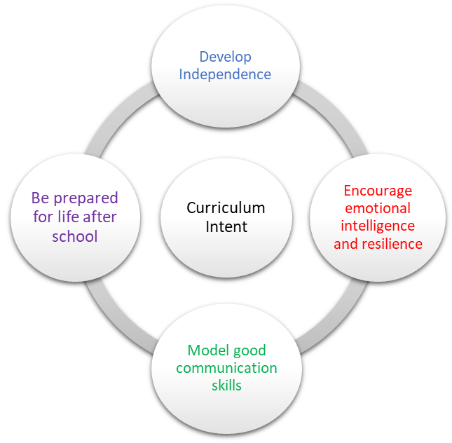 | School Pedagogy:  Launchpad Tuition has a child centred pedagogy. The school adopts an inclusive, transformative pedagogy as we believe that a child’s ‘capacity to learn can change and be changed for the better as a result of what happens and what people do in the present’ (Hart et al. 2004, P166). Learning is about shared communication between staff and pupils. Implementation of our curriculum intent is underpinned by Rosenshine’s 10 Principles of Instruction (Rosenshine, 2012). All learning sessions include the following elements; reference to curriculum intent, recap of knowledge and skills, assessment for learning and pupil voice.  Subject Specific Pedagogy:  Here at Launchpad Tuition, we know how vital Mathematics is to a student’s future. We aim to foster a love of learning and encourage the students to be motivated learners; challenging themselves to achieve to the best of their ability. We promote a positive attitude to mathematics and themselves; through investigations, problem solving and accepting that mistakes help us to grow and learn. We aim to cultivate an environment that creates students who are resilient, questioning, resourceful, self-sufficient and ultimately able to apply all the skills and knowledge that they have acquired to unfamiliar situations. We teach mathematics in line with the National Curriculum (2014), however this will be differentiated as required in consideration of individual starting points and to meet individual learning needs. We also work to ensure that our pupils see the real-life and cross-curricular links that are within this broad subject. The curriculum is progressive and builds on skills learnt in prior years. Some students may have gaps in this prior learning and due to each young person having differing learning needs, gifts or talents, some pupils may not have yet mastered the component skills required to progress, so as a provision we will adapt accordingly. Teaching is rigorous, personalised, innovative and student-centered. We implement individual intervention strategies for each pupils which may include 1 to 1 interventions, study support and adjustments for particular learning styles. Careful sequencing of topics provides the opportunity to revisit, reinforce and apply knowledge, understanding and skills learned whilst making connections across the curriculum, to real-life scenarios and other subjects. We ensure to interleave and link topics to allow pupils to regularly revisit topics, supporting recall and retrieval. Concrete and pictorial resources are utilised to support the development of conceptual understanding, when appropriate, to support new concepts or as part of individuals’ learning needs. Pupils engage in sustained practice with increasingly complex problems over time and are encouraged to reason and discuss their thinking. We teach using Multiple Teaching Methods, deepening pupils understanding through concrete methods. This also allows for support from students from a range of previous settings. We do these through guided, independent and group work. We also build in communication skills, games and investigations, when possible. This is to cement knowledge, learn through play, support the whole pupil and to challenge the maths anxiety that many pupils present with. The curriculum is designed to promote progress, challenge and achievement for all.  Whilst we aim for all pupils to leave with a GCSE grade, this is not suitable for all and the most suitable qualification for each individual will be selected, so that every child reaches their full potential. Therefore, other qualifications on offer may include Entry Level certificates and Functional Skills Level 1.
Subject Intent:

Mathematics can help us better understand and describe the world around us. Recognising the importance of mathematics in life and in society contributes to living safe, healthy and fulfilling lives. Understanding there is a purpose to Maths beyond the classroom is our curriculum intent. The importance of mathematics is evident in our personal lives from calculating the number of tins of paint needed when decorating, managing expenses organising and planning a journey, to estimating bills. Some career options require subject-specific knowledge but a wider variety depend mainly on 'higher-order skills' and problem solving, being able to think logically or systemically, handle data or analyse problems. Our curriculum is designed to give a good mathematical education and to help develop these higher-order skills. We want pupils to respect others’ values and opinions, work as a team and have a sense of unity through helping or supporting others. We want students to aspire to be the best that they can be and reach their individual potential, especially having confidence and resilience to face any challenges.

KS3: At Key Stage 3 each pupil follows a maths curriculum that aims to progressively increase their knowledge, self-confidence and interest in the subject. In some cases, pupils may have missed a substantial amount of mathematical learning prior to joining our unit, and we understand that it is important to concentrate on addressing any specific difficulties which result from this. We work towards the National Curriculum appropriate to their age level, however, depending on the individual’s needs and situation it is sometimes necessary to look at alternative qualifications, such as Entry Level qualifications or units. To support each pupil, tasks may need to be differentiated appropriately for individual abilities, prior knowledge and aptitude for the subject. We aim to build confidence in all areas of maths and address any gaps in knowledge, misconceptions and weaknesses. The scheme of work is tailored to the individual cohort, as students can come at a range of ages, with varied previous knowledge and levels. We aim to challenge the students to achieve to the best of their ability by using a range of teaching techniques, resources and activities.

KS4: For students in Key Stage 4, most pupils will aim to complete GCSE examinations. In order to achieve this students must become numerate individuals, who are able to recall and apply knowledge rapidly and accurately in a variety of routine and non-routine problems. At Key Stage 4, pupils are expected to undertake extended questions, solve more complex problems and to develop their skills in communicating the results clearly. If students are able, they will be entered for the GCSE exam at either Foundation or Higher Tier. They can achieve Grade 1- 9 and this is determine by three papers: one non-calculator and two calculator. The course develops knowledge, skills and understanding of Number, Algebra, Geometry and Measures, Statistics, and Mathematical Processes and Applications. Students will be supported in their studies with a variety of revision materials. We also consider the individual learning styles of pupils in the cohort as well as their prior knowledge. If a pupil is not yet ready to access the GCSE examination, an alternative qualification is considered. There are a range of options available, and depending on the needs of the pupil, the qualification that will allow them to achieve to the best of their ability is selected. Some options include: Entry Level Certificates, Entry Level units and Functional skills exams. To ensure students achieve their full potential, there are also revision sessions, intervention sessions and after school clubs.

Key Stage and Subject Long Term Plan | Topic/Learning Pathway | Key Vocabulary | Links to previous learning (Component Skills) | Links to wider curriculum
Autumn 1 | Algebra basics  Simplifying Algebra  Factorising  Expanding brackets  Rearranging algebra  Expressions from words and diagrams  Inequalities on a number line  Solving inequalities | Co- efficient, Value, Constant, Expression, Equation,  Formula, Identity,  Variable, Solve,  Solution, Term,  Inequality, Greater  than, Less than, Equal  to, Solve, Solution,  Variable, Simplify,  Expand, Factorise,  Linear, Binomial,  Polynomial, Variable | - Algebraic notation  - Simplifying expressions  - The four operations  - Powers and indices  - Fact families and inverses  - Brackets  - The order of operations  - Comparing and ordering  - numbers  - Inequality notation  - HCF | Real life- costings  Science- Formulae
Autumn 2  Autumn 2  (con.) | Areas and perimeter (assess if recap.)  Volumes  Surface areas  Four transformations (start) | 2D shape names, parallel, perpendicular, right angle, cm, mm, m, cm², mm², m², units, formula, Circumference, Diameter, Radius, Sector, Segment,  Centre, Area, Perimeter,  Circle, Semi-circle,  Fractional, Length,  Volume, Cylinder, Cone,  Sphere, Surface Area,  Face, Edge, Vertex,  Vertices,  Transform, Transformation, Congruence, Congruent, Similar, Similarity, Rotate, Rotation, Translate, Translation, Reflect, Reflection, Symmetry, Rotational symmetry, Vector, Direction, Coordinate, Axis, Origin Similar, Similarity, Enlarge, Enlargement, Congruence, Congruent, Scale Factor, Proportion, Multiply, Multiplication, Divide, Division, Side, Angle, Symmetry, symmetrical, horizontal, vertical, diagonal, reflect, reflection, orientation, congruence | - Types of angle  - Algebraic notation  - Using formula  - Using a scientific calculator  - Ratio and ratio notation  - Types of triangle  - Formula for the area of a rectangle  - Estimating area  - Types of quadrilaterals  - Parts of a circle  - Identifying and name 2D Shapes  - Properties of 2D shapes  - Nets of 2D shapes  - Identifying and naming 2D shapes and their properties  - Coordinates in all 4 quadrants  - Lines parallel to the axis  - y=x, | Geography: Calculating distance  Science- Volumes,  Art- 2D shapes, equipment, design  Real life- Costings, future careers  Art: Working with shapes. Rotation and rotational symmetry, reflection in images  ICT: Editing photographs or images on PC
Spring 1 | Transformations (con. Combined for H)  Probability basics  Calculating probabilities  Outcomes  Sample space diagrams  Experimental probabilities  And/or rule  Probability trees  Frequency tree | Likelihood, probability, unlikely, even chance, equal, likely, certain, outcome, combination, relative frequency, experimental probability, Systematic, convergence, bias, independent, 0, 1 , dependent, event,  Sample, Theoretical, Outcome, Estimate, | Calculating with fractions  Language of probability | Science: Experimental data, bias and likelihood  Business: Analysing data  Sociology: Analysing data
Spring 2 | Mean, median, mode, range  Grouped frequencies and tables  Calculating with fractions  FDP  Calculating with percentages and percentage change | Average, Mode, Median, Mean, Range, Distribution, Trend, Relationship, Outlier, Order, Anomalous,  Fraction, integer, mixed number, improper, part, whole, numerator, denominator, product, divisor, quotient, multiply, divide, reciprocal, decimal, percent, percentage, increase, decrease, growth, decay, decimal, multiplier, equivalent | The four operations  Ordering integers and decimals  - Fraction notation  - Improper fractions and mixed numbers  - Equivalent fractions  - Adding and subtracting fractions  - Mental and written methods of multiplication and division  - Inverse operations | Science- measuring averages  Business- Data collected  Sociology- analysing data  Science: Working with parts of a whole. Calculating with fractions  Real life- cost and savings  Business- costs, profit and loses  Sociology – changes in opinion  Science-changes in results
Summer 1  Summer 1  (con.) | Collecting data  Charts and representing data  Time series  Histograms  Two way tables  (Assess other data forms knowledge) | Data, Correlation, Positive, Negative, Relationship, Trend, Linear, Outlier, Frequency, Tally, Discrete, Continuous, Quantitative, Qualitative, Grouped, Ungrouped, Class, Interval, Scale, Statistical, Enquiry, Data, Questionnaire, Leading, Bias, Open, Closed, Interpret, Trend, Relationship, Pictogram, Horizontal, Vertical, Scale, Interval, Compound, Bar chart, Line graph, Grouped, Ungrouped, Pie chart, Range, Distribution, Advantages, Disadvantages, Pie chart, Estimate, Quarter | - Types of angles  - Estimation on calculations  - Four operations | Science: Collecting, presenting and interpreting data. Hypothesising. Drawing conclusions. Experimental  data.  Business: Surveys  Sociology: understanding findings and collecting own data  English: Communicating findings
Summer 2 | Functions  Inequalities on a graph  Sequences | Function, Inverse,  Composite, Substitute,  Evaluate, Solve, Variable  Expression, Equation,  Formula, Identity,  Variable, Solve,  Solution, Term,  Inequality, Greater  than, Less than, Equal  to, Solve, Solution,  Variable, Simplify,  Expand, Factorise,  Linear, Binomial,  Polynomial, Variable  Term, Position,  Sequence, Linear,  Arithmetic, Geometric,  Quadratic, Increase,  Decrease, Ascending,  Descending, nth tern, term to term, pattern, Generate, Value | - Identifying and naming 2D  - shapes  - Properties of 2D shapes  - Types of angles  - Forming and solving  - algebraic equations  - Substitution  - Understand how to find the unknown  - Basic number lines  - Number patterns  - The four operations  - Powers and indices  - Algebraic notation  - Writing expressions  - Multiples | Art- patterns  Science- patterns and sequences

